LIONS CLUB INTERNATIONAL, DISTRICT 201V3 INC.
ANNUAL GENERAL MEETING AND 47th CONVENTION
OAKS, LOGAN PARK, HOWITT STREET WARRAGUL
27, 28 & 29 OCTOBER 2023

 | Title  (PDG etc) | Surname |  | Given Names  (As it will appear on your Convention Badge)
Lion
Partner
Leo
Guest
CLUB |  |  |  | District
Address
 |  |  | State |  | Post Code
Phone |  |  | Mobile
Email
Is this your first Convention? |  | Yes | No | (Please circle)
We are staying at:
Special Dietary requirements: |  |  |  | Special Physical Needs:
MEALS AND FUNCTIONS – Choose individually please
Date | Day | Function | Time | Cost PP | Number | Amount $
27/10/2023 | Friday | Welcome Sausage Sizzle | 4.00pm –6.00pm | FREE
27/10/2023 | Friday | Informal Reception  Drinks at Bar Prices | 7.00pm | $5
28/10/2023 | Saturday | Breakfast | 7.00am | $5
28/10/2023 | Saturday | Lunch | Approx. 12.30pm | $15
28/10/2023 | Saturday | Dinner Dance – Warragul Country Club – (120 Max)  Drinks at Bar Prices | 7.00pm -11.00pm | $25
29/10/2023 | Sunday | Breakfast | 7.00am | $5
29/10/2023 | Sunday | BBQ Lunch – Oaks- Drinks at Bar Prices. | Approx. 12.30pm | $15
Convention Pins (120 only) |  |  |  | $7
 |  |  | TOTAL: |  |  | $
Personal Cheque | Money Order | EFT | Total Amount: $

Completed Registration Forms should be sent to: Email iandebruyne@gmail.com
OR mail to: The Secretary, Lions District 201V3 2023 Convention Secretary
PO Box 45 Warragul Vic 3820

Preferred payment by EFT to NAB – Account name: LCI DISTRICT 201V3 BSB: 083953
Account Number: 549887518. Please quote your name as reference.

Please address all correspondence to:
The Secretary, Zone 6 V3 2023 Convention Committee,
PO Box 45 Warragul Vic 3820
or contact either:
Convention Chairman, Lion Geoff Anderson on 0412 285 913 or
Convention Secretary, Lion PDG Terry Hayler on 0437 353 651

2023 DISTRICT 201V3 CONVENTION HOSTED BY THE LION’S CLUBS OF ZONE 6

Dear Lion
Attached is a brief information in relation to registering for the 47th Annual District Convention, to be held on Friday 27th, Saturday 28th and Sunday 29th October 2023.
VENUE
REGISTRATIONS & BUSINESS SESSIONS are at The Oaks, Logan Park, Howitt St., Warragul 3820
REGISTRATION FORMS & PAYMENT
Download your Registration Form from the 201V3 website: www.201v3.lions.org.au OR
Cabinet Secretary will email registration forms to Clubs.
Payments can be made by either EFT, cheque or postal order.
FRIDAY NIGHT INFORMAL RECEPTION
The Informal Reception will commence at 8.30pm
SATURDAY NIGHT DINNER DANCE Band: The Hoffmans
To be held at Warragul Country Club, Sutton Street, Warragul Vic 3820 – 120 max number attending first in will be allocated seats.
Members, please arrange your own transport to and from the venue.

ALL REGISTRATIONS ARE TO BE FINALISED BY THE CLOSING DATE
MONDAY 16th OCTOBER 2023

Conventioneer & Delegate Registration will be open at 3pm Friday & 7am Saturday
Start times for Convention are Friday 7pm, Saturday 8.30am & Sunday 9am

A SELECTION OF ACCOMMODATION IS AVAILABLE IN WARRAGUL AND SURROUNDING TOWNS as per attached lists. Please make your own bookings.

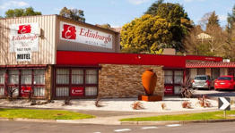 | Edinburgh Motel  Warragul | 61 Princes Way, Warragul VIC 3820  (03) 5622 3339  (Convention Motel)
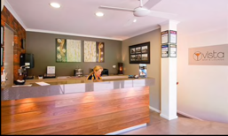 | Warragul Views Motel  Warragul | 50 Rulemount Rd, Warragul VIC 3820  (03) 5623 5222
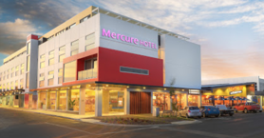 | Mercure Hotel  Warragul | 23 Mason St, Warragul VIC 3820  (03) 5618 3500
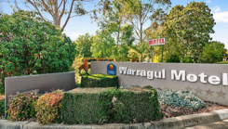 | Comfort Inn Motel  Warragul | 1845 Princes Way, Warragul VIC 3820  (03) 5623 2189
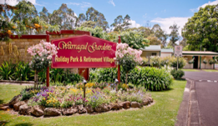 | Warragul Gardens Holiday Park | 44 Burke St, Warragul VIC 3820  (03) 5623 2707
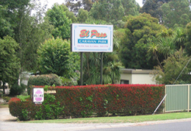 | El Passo Caravan Park  Drouin | 62-270 Princes Way, Drouin VIC 3818  (03) 5625 1710
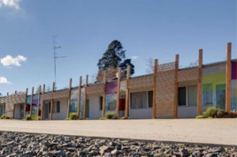 | Comfort Inn  Drouin | 275 Princes Way, Drouin VIC 3818  (03) 5625 3296
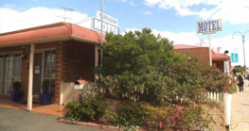 | Comfort Inn Motel  Yarragon | 1845 Princes Way, Warragul VIC 3820  (03) 5623 2189

We appreciate the support given by our valuable 2023 Zone 6 Family V3 Convention Sponsors.

Drouin & District Community Bank Neerim & District Community Bank

Trafalgar & District Community Bank BAW BAW SHIRE

Warragul Country Club RMI Print

Dahlsen’s Building Supplies

Hocking Stuart Real Estate

Anderson McCormack P/L Nielsens Funeral Services – Warragul & Drouin

Tyrells Accountants (Moe & Warragul)

Wayne Farnham MP (State) Russell Broadbent MP (Federal)

Travel Plus (John Daniels)

Malady Electrical Bakers Delight Warragul

Leigh Herbel Constructions P/L

Warragul Sporting and Social Club

Lions Clubs of Warragul & Yarragon & all Zone 6 Clubs.

Blackwood’s Readymix P/L

Valleymotorgoup (Glenn Chenoweth)

Harriet Shing MP Eastern Victoria Darren Chester MP La Trobe Valley

Bunnings Warehouse P/

